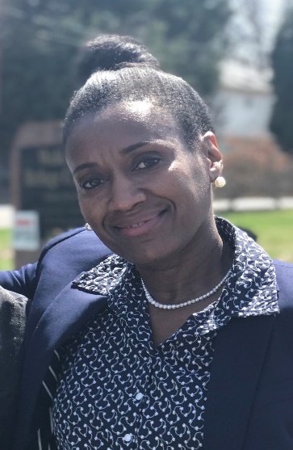
Laborers in the Vineyard

Laurabelle McKie

Welcome, Laurabelle!

Laurabelle is one of Refuge Church’s newest members. With her infectious smile and dynamic personality, Laurabelle answers a few questions to shares a few tidbits about herself.

R: When’s your birthday?
L: July 15:)

R: What is one important thing you have learned from this ministry?
L: This Ministry has SHOWN me that you truly love and care about your congregation.

R: When did you move to this area?
L: Native Washingtonian - I’ve been living in the Silver Spring Area since 16 years old

R: What are your hobbies?
L: I love photography and sports.

R: How can we pray for you?
L: Please pray for my entire family but more specifically my relationship with mom.

R: What is your favorite scripture and why:
L: Isaiah 54:17 No weapons formed against thee shall prosper! Many weapons have been formed against me in my 52 years. God knows I have been through some storms, as a matter of fact, tornadoes. Although I’ve come out with many lessons learned, I was barely scratched because my God has me covered.

R: What else would you like to share with us?
L: I am married and a proud mom of 3 boys and 2 girls. Also, a proud grandma of 2. I love my God! God blessed me with the gift of serving and leadership and I want to utilize those gifts within the Refuge Ministries.

And Laurabelle, we are excited that you have joined this local vineyard! We look forward to serving our Lord with you!

